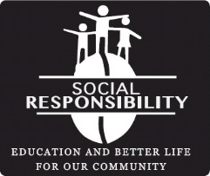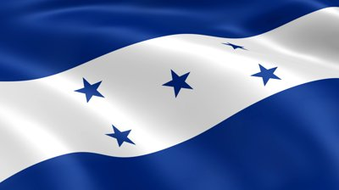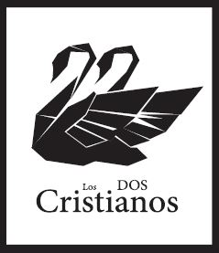

**A Social Enterprise.**

Los Dos Cristianos (The Two Christians) was formed to serve people. During a missions trip to Honduras (one of the poorest countries in the world) we were struck by the negative impact poverty has on a country. We were inspired to act – our mission – to form one of the greatest coffee companies in the world and to give back to the Missions serving the people of Honduras. Our plan! – to import exceptional coffee into the global supply chain, Roast Locally for business’ and open Coffee shops to serve only the best fresh roasted Coffee.

**Coffee Shop Barista/Server – North Port**

**What we are looking for:** We are a growing company and need talent. Do you have integrity, a passion for service, humility, curiosity? Are you organized? Do you want to grow with us? Please send us your resume.

**Job description:** You will be responsible for brewing and serving espresso and brewed coffee/donuts.

**Requirements:** No previous Barista or Coffee Shop skills are needed but are an advantage. The Candidate must have:

* Friendly and outgoing personality
* A desire to learn – Curious
* Excellent oral communication skills
* Passion for service

**We will teach you:**

Level 1 – Barista Skills – and if you excel additional skills can be taught in areas of Sales, Green Bean Roasting, Coffee Cupping, selecting, Brokering – store management.

Send resume to: losdoscristianos@gmail.com

Endless possibilities. **Careers with Los Dos Cristianos Coffee.**